Lab-6 Prudhvi Nalluri

Murali Krishna Kalvakuri

Jagadeesh Tirumalasetty

Sai Sowmya Kamaraju

We have chosen the 2048 tile game android app. We used sensor tag to collect the readings.

Usually this is a touch based game that uses movements in four directions. We used sensor tag to collect up, down, right, left movements to add the tiles with same number to generate largest possible tile.

We collected the data from sensor tag and pushed it to HBase. We generated training to obtain results by invoking web services of big data. It shows how many games played in a day during each hour. And the data collected is for two days.

We represented these results graphically by using the source code which is submitted in the github.

The below figure is AChartEngine demo. This is to generate a graphical report of considered activity list.

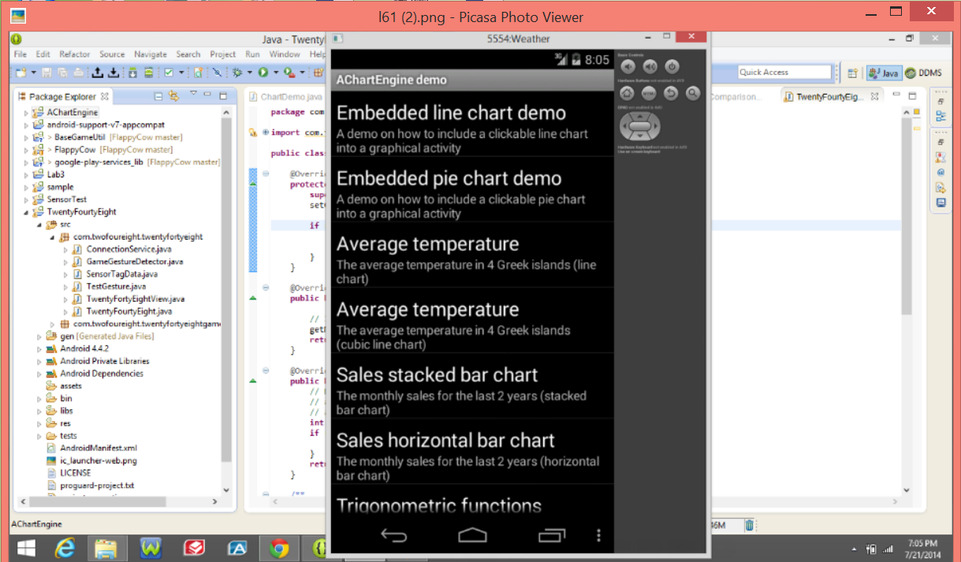

The below figure shows the changes made to the source code. We set labels, axes and different colors chosen to represent the graph. All these are defined in the source code shown below to generate graphical representation.

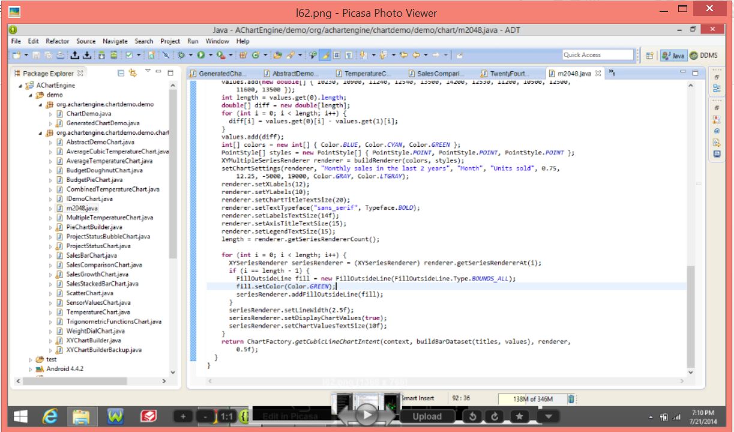

The below figure is the graphical representation of the collected data. It shows number of games played on day one and day two which are 7/12 and 7/13. The difference in number of plays between the corresponding days is also shown. There are different colors used each depicting particular classification.The data collected on each day has number of plays played each hour.

